User journey 2FA without smartcard:
Access the link: https://ciam.epo.org/registration
- Create an EPO account

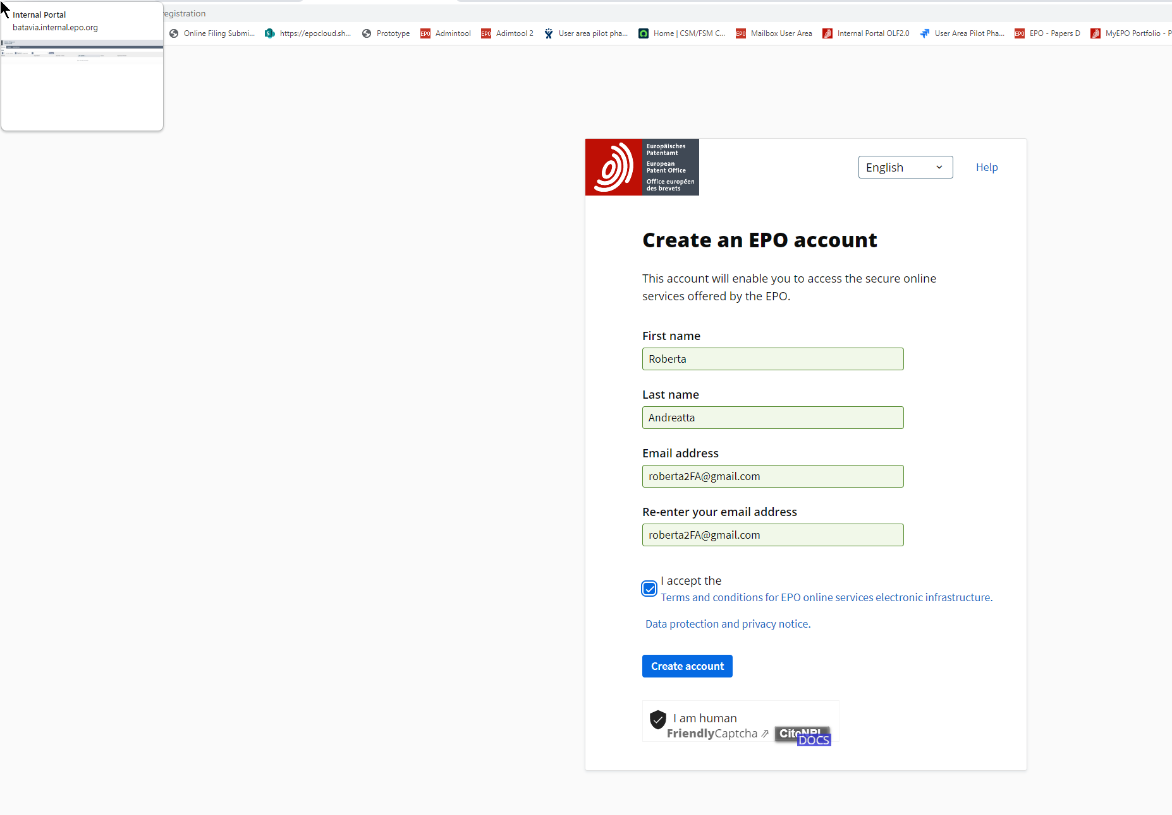
- An email is sent to the attention of the user in order to set up the password (1st step authenticator)

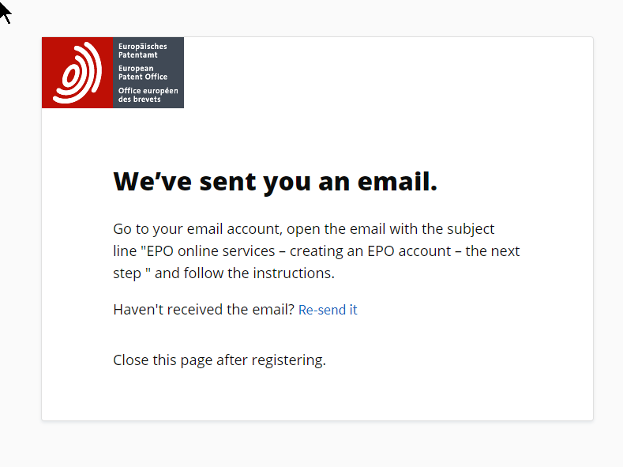

- Set up the password

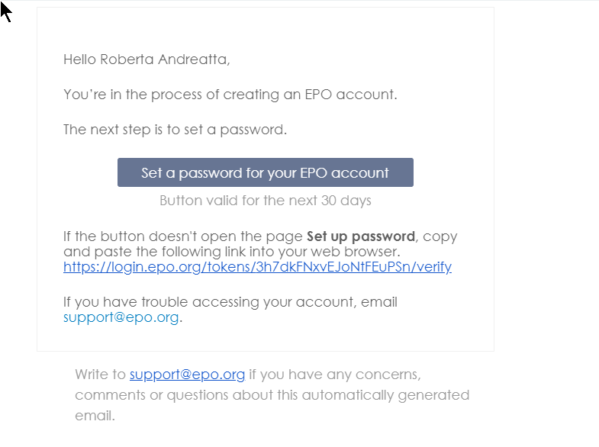

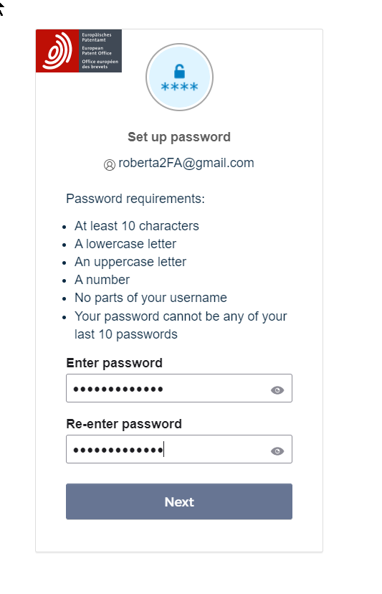

Select the 2nd authenticator method:
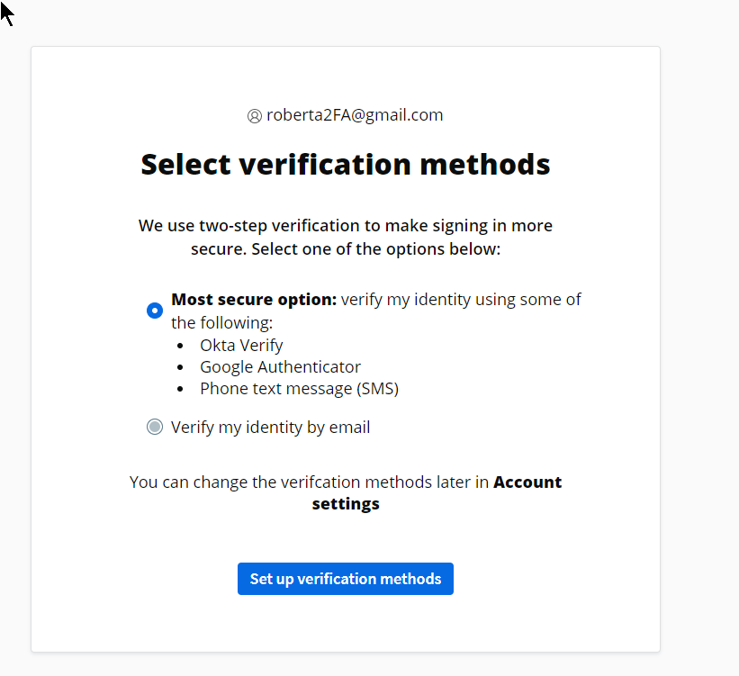
Follow the “complete set-up in MyEPO Portfolio”
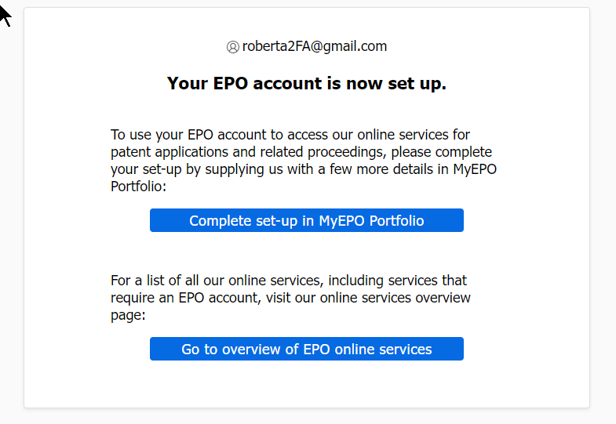
You can then choose among SMS, OKTA verify, Google authenticator and email.

- The user will be notified via email that the account authentification has been set up.
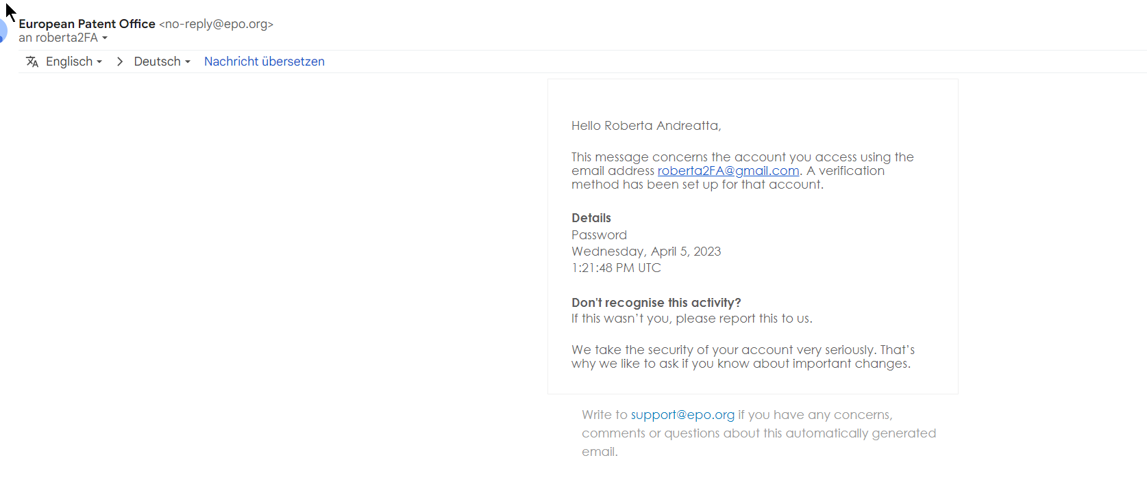

Once the user access the MyEPO Portfolio will be asked to fill in the registration form which will create the portal for the company in admintool. Once submitted the user will receive the mail notification with the form in attachment that need to be signed and sent via mail to support@epo.org
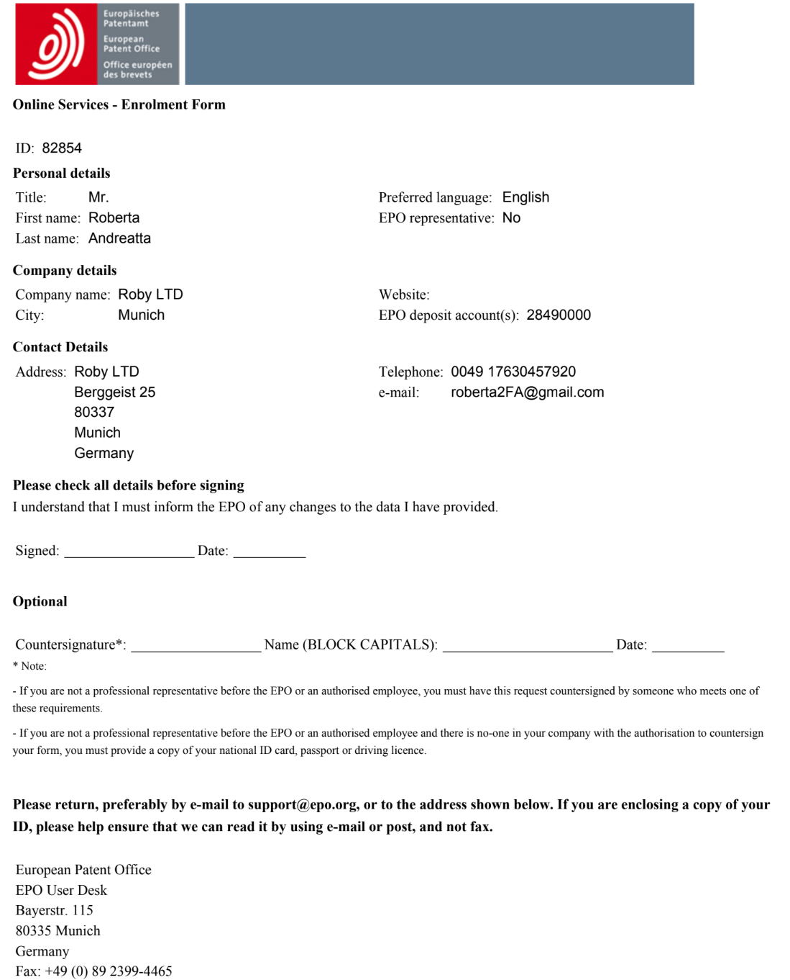

- The request will be treated internally at the EPO and once accepted and successfully completed another notification mail will inform the user that now the account is activated.

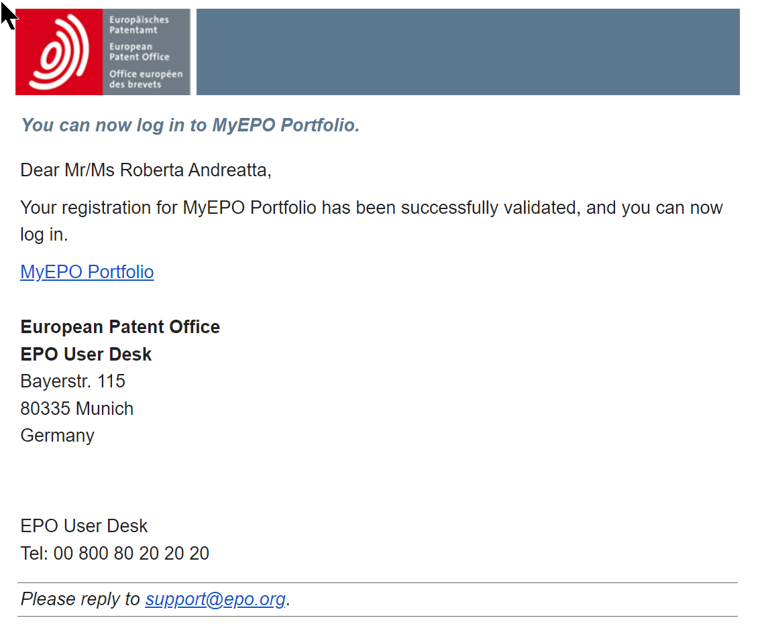

- If the user is the first to enrol for a newly created company do not forget to assign this person “admin right” and possibly the access to the mailbox otherwise he/she will not be able to log on to MyEPO Portfolio. For the moment the feature to accept the role as administrator when someone is the first user is not yet implemented. If there is already an administrator will be the duty of the administrator to grant access to the new user. (For Americans not yet used to our system better to grant them access to the Mailbox already)

- To add new way of authentication instruct the user to click “need help”:
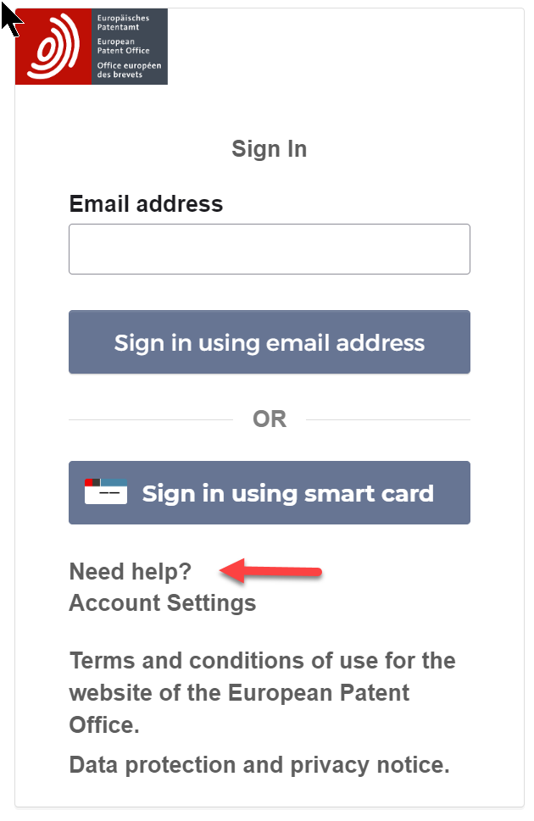

Scroll to this chapter and click on “account page:

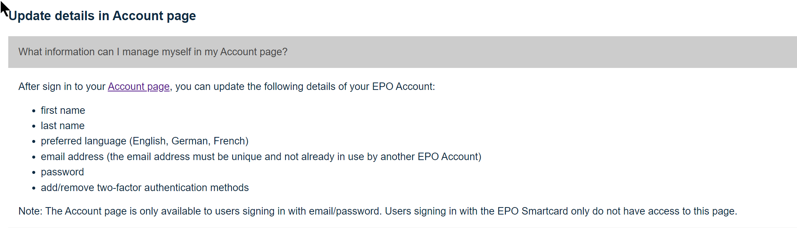

This will bring the user to the log in page, after giving email address and password by clicking on “unblock settings” will permit to change your credantial, the language access to MyEPO Portfolio i.e EN to FR, set another method of authentification.
